Fairy Look- Colors will vary based on costume color; will not use rhinestones just sparkles
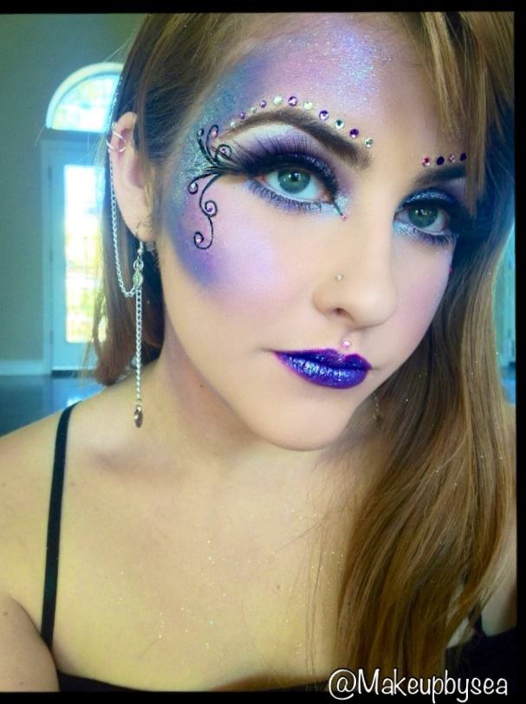

Fairy Hair: Down with curls
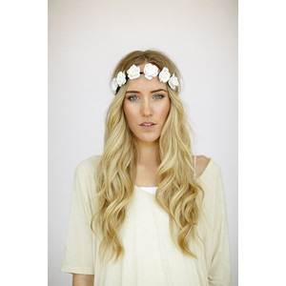

Pirate look- Heavy eyeliner with a dark red lip, smoky eyeshadow
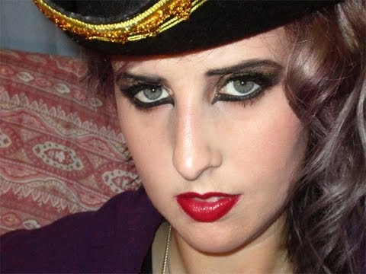
Pirate Hair: You need to have hair in braids the day of the show; take out braids, tease hair and have some small braids throughout

Indians: War Paint Makeup; can do stripes, possible some dots
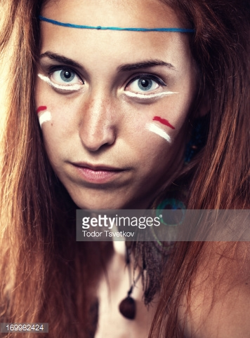

Indian Hair: Either two pigtail braids or one braid

Wendy Makeup: Blush, eyeliner, soft eyeshadow, pink lips
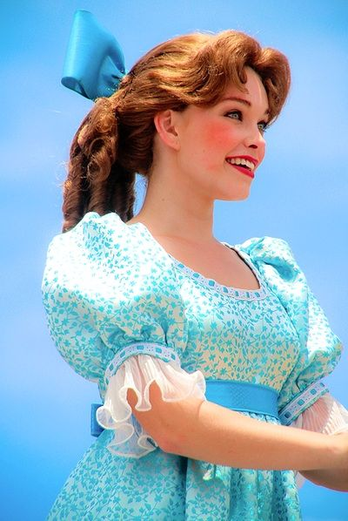
Wendy Hair: Curls with bow
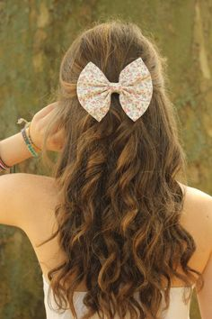

Tinkerbell: Golds, greens, straight lines from eye (gold/green not black); gold sparkles
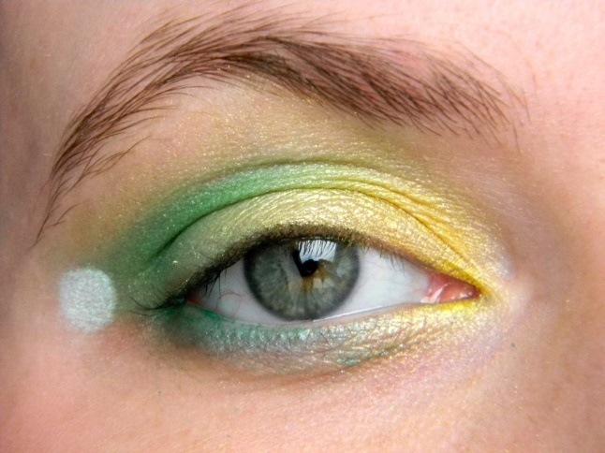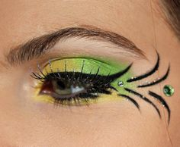
Tinkerbell hair:Sock Bun
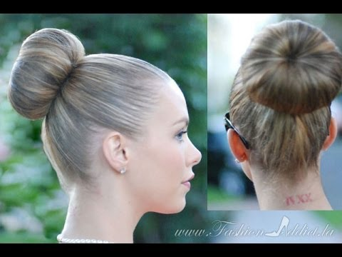

Lost boys: Have the basic foundation/mascara; Hair- pull up into hat

Michael- Have basic foundation/masacara, add blush; Hair-low bun

